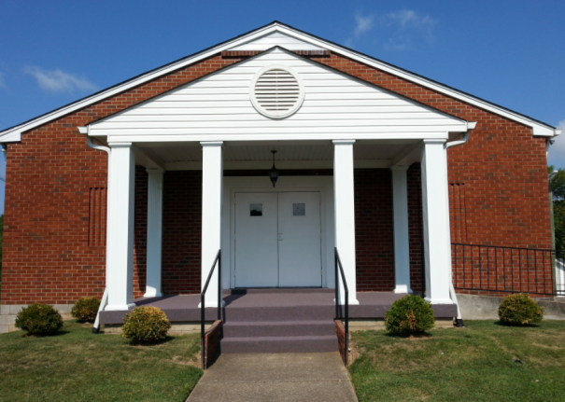
April 12, 2015
Faith Missionary Baptist Church
2243 Burbank Avenue
Nashville TN 37210

*** Sunday School – 10am ***
*** Worship Service – 11am ***

Pastor: Elder Benny Maggart

Church leaders

Pastor: Elder Benny Maggart
Deacons: Don Langford James Quinn
Jimmy Hicks
Clerk: Billy Clemons
Website: www.faithchurchnashville.com
Webmaster: Terry Parker

Calendar & events

Kristy Parker Bridal Shower – April 12 - Following morning church service.

God With Us – Women’s Fellowship – Tues, Apr 21st – 6:30pm Please pray for Sis Martha Moore (Linda Maggart’s mother) from New Bethel MB Church
Thanks, Cindy!

2nd Annual Pancake Breakfast Fellowship – Sat, May 2nd 9am

Prayer Requests
- Our Church family and the lost
- Pray that Grace will find her way back to church, remember her son that has cancer.
- Remember Jimmy's co-worker’s and their families.
- Shoulders family.
- Remember our shut ins.
Thanks, Jean!

When you are going through something hard and wonder where God is, remember the Teacher is always quiet during a test!
Thanks, Jean!
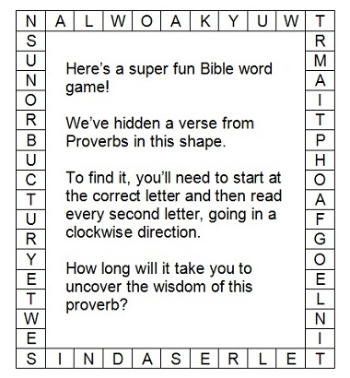

Members or Family Members in Nursing Homes Or Shut-ins
We hope our “temporary” status folk will be out and about soon.
If you know of others who need to be added, please let us know.

Mrs. June Hicks (Jimmy’s Mom) -Temporary Status
1319 Saturn Drive
Nashville, TN 37217
Mrs. Rhoda Kemp (Birthday 1-12)
Stonescrest Assisted Living Facility
2561 Highway 52 E. # 16
Lafayette, TN. 37083

E. W. Hassell (B..D. 5-20)
7537 River Road
Nashville, TN 37209

Mrs. Esma Trapp
Bethany Health Care Center #217-A
421 Ocala Dr
Nashville, TN 37211

Mrs. Mary Jo Whaley (Temporary) B.D. 6-24
208 Margo Lane
Nashville, TN 37211

Mrs. Bonnie Moore (Maggart family sister-in-law) (Temp.Status)
42 Terry Lane
Trinity, Alabama 35673-6519

Mrs. Shwanda Shoulders – Virgil & Barbara’s daughter-in-law
365 Double Branch Road (Temp.)
Dickson, TN 37055
Thanks, Joyce Callis!

Pastor’s comments

Updated Visiting Preacher Schedule
Apr 26 Matthew Clark
May 3 Derrick Dickens
May 24 Spencer Anderson
June 7 Mike Turnipseed

Revivals to pray for:
Thursday 4/16 Hope MBC, Manchester, TN

Pastor's Comments

Last week concluded our coverage of the 18 articles of the New Hampshire Declaration Of Faith. I gave only a brief account of each article. More scriptures can be found on our church web site,
faithchurchnashville.com, or in the Baptist Church Manual by J. M. Pendleton, DD or by searching the internet. For most of you this has been a refresher of these principles true Baptist adhere to. For some I hope it sparked an interest to learn more about our beliefs.

We are a peculiar people, different from the world and other so called Christian faiths. It is our responsibility to learn what Baptist believe and abide by those tenets to live our lives for Christ. The church has the responsibility to teach these beliefs, but that effort is greatly hindered by the failure of members to attend the services where they are taught - worship and Sunday School services. Setting aside time to attend the Lord's house is very little compared to the sacrifice Jesus made to save your soul and provide eternal life. If we are too busy to meet with God's people to worship and learn of the Lord, then we ARE too busy!

