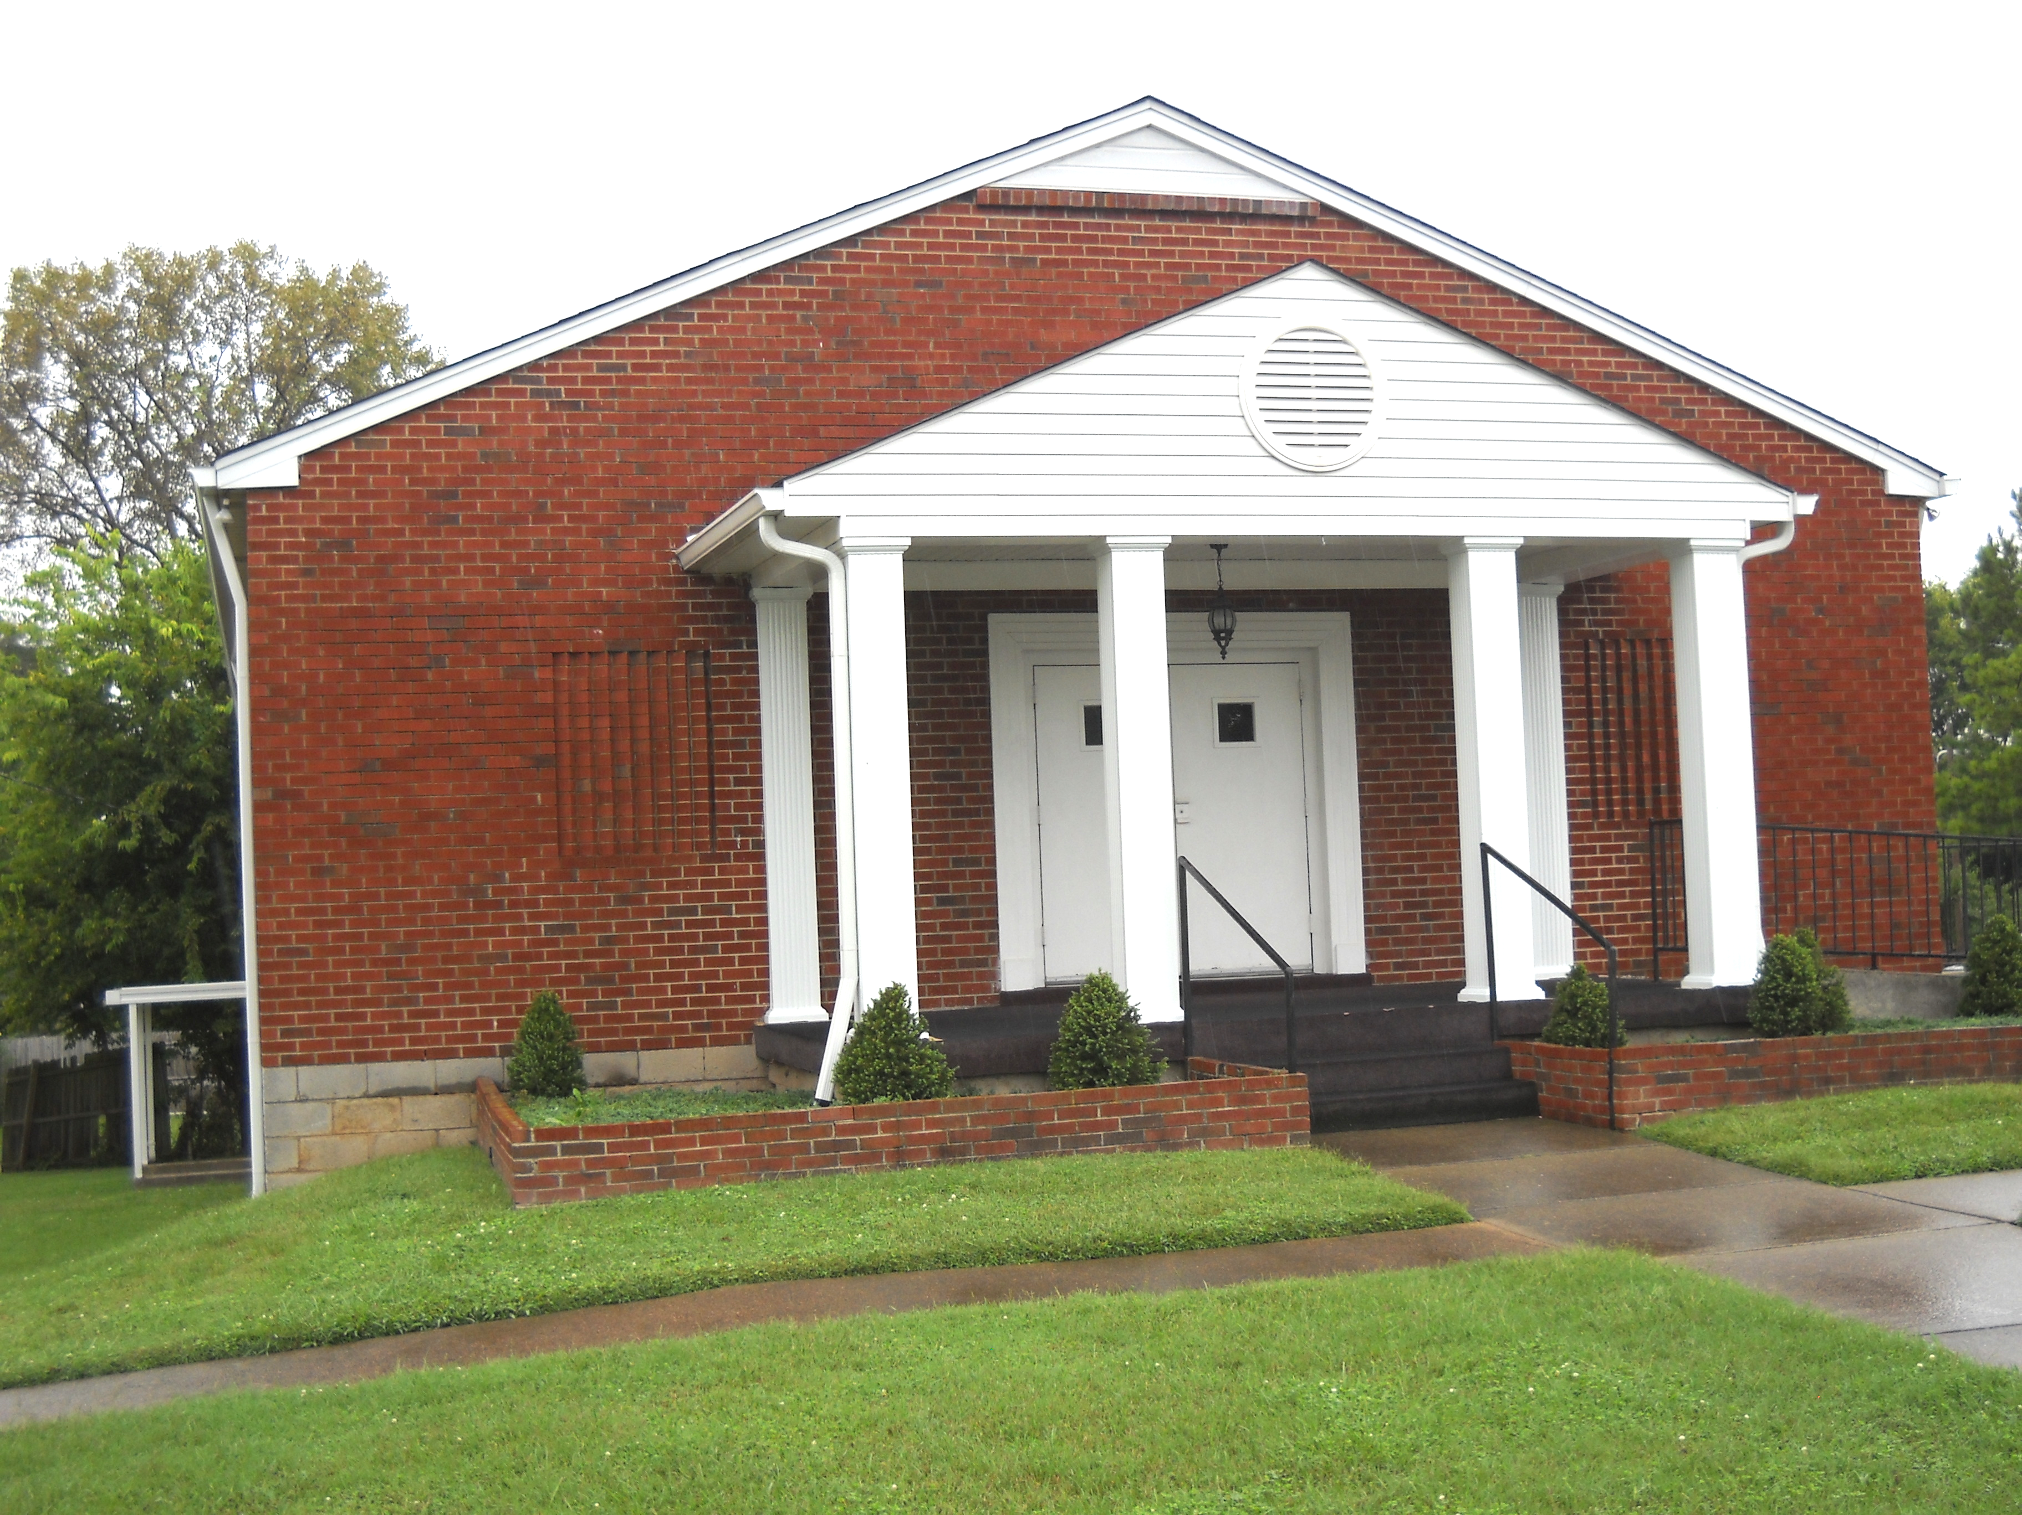

FAITH OLD-TIME MISSIONARY BAPTIST
CHURCH BULLETIN
July 1, 2012
2243 Burbank Avenue (Corner of Rose & Burbank)
Nashville, TN 37210
Sunday School: 10:00 a.m.
Morning Worship Services 11:00 a.m.
Evening Worship Services 6:00 p.m.
Church Website: http//www.faithchurchnashville.com/
Pastor: Elder Barry Armour 615-822-4681-615-812-6204
Pastor Email: faithchurchnashville@gmail.com
Music Director: Bro. Bert Lanier
Sunday School Supt.: Bro. Terry Parker
Church Clerk: Bro. Billy Clemons
Deacons: Bro. Jimmy Hicks Bro. Bert Lanier
Bro. Don Langford Bro. James Quinn

“Thus saith the Lord, Stand ye in the ways , and see, and ask for the old paths, where is the good way. And walk therein, and ye shall find rest for your souls. But they said, We will not walk therein.”

Jeremiah 6:16



God With Us Women’s Fellowship

Meetings will be suspended for June and July to allow embers to be able to attend Revival meetings at our
Sister churches.

Woodbury Mission

The Woodbury Mission will begin a Revival the second Sunday in July, July 8, beginning at 7:30. There are four ministers helping with this mission. They are: Bro. Gayle Snoddy, Bro. Kenneth Summers, Bro. Dustin Summers and Bro. Mark Gregory. Please try to support their efforts with your attendance. A nine year old boy has been seeking the Lord there.

APPRECIATION FOR GOOD PREACHING We were blessed in our revival to have every night a number of visitors and very good preaching. We appreciate our pastor and the very good help selected for our revival.

REVIVALS & CHURCH EVENTS OF FAITH CHURCH AND SISTER CHURCHES

Antioch Missionary Baptist Church – 6659 Galen Rd., Lafayette, TN. Revival beginning Sunday, July 1, 7:30 p.m. Pastor: Elder Walter Andrews, assisted by Elder David Swindle and Bro. Barry Brawner.

Gladdice Missionary Baptist Church - 1291 Salt Lick Creek, Pleasant Shade, TN. Revival beginning, Sunday, July 1, 7:00 p.m. Pastor Elder Charles Patterson assisted by Elder Jason Wheeley.

Mt. Tabor Missionary Baptist Church – Pleasant Shade, TN. Revival beginning Sunday, July 1, 11:00 a.m. and 7:30 p.m. Pastor: Elder Michael Horton, assisted by Elder Junior Dickerson.

Rocky Mound Missionary Baptist Church – 5500 Rocky Mound Rd., Westmoreland, TN. Revival beginning Sunday, July 1, 11:00 a.m. and 7:30 p.m. Pastor: Elder Don Watts and assisted bt /elder Stephen Skinner.

Harmony Missionary Baptist Church – 1044 E. Trinity Lane, Nashville, TN. Revival beginning Sunday, June 24, 7:00 p.m. Pastor (No name) assisted by a helper (no name).

Lulu Missionary Baptist Church – 210 17th Avenue E., Springfield, TN. Revival beginning Sunday, June 24, 7:00 p.m. Pastor: Elder Frank Kirby, assisted by Elder Jeremy Sisk.

Old Fashion Gospel Hour – Sundays, 9:00 a.m. – Channel 17 and 28.
Website: ofghour@gmail.com

REMEMBER IN PRAYER

Alexandria Swindle was seeking the Lord in our Revival. Please keep her in your prayers.

Cindy requested prayer for some customers who come in and talk to them at their business. She needs our prayers too that she will be able to answer questions about their seeking the Lord.

Continue to pray for Virgil and Barbara Shoulders’ grandson, Zack, who has been having some tests and is having health concerns. Please pray for his speedy recovery.

Ian Herlein has a friend who has a 2 ½ year old daughter who has to have reconstructive surgery and this will require her to be in a body cast for awhile. Pray for this little girl.

Continue to pray for a very young girl, Mary Keith, who is a friend of the Sisk family, has stage four cancer. Her condition is not good.

D0
D0 RE MI SINGING SCHOOL CAMP

There was a group from Faith who attended this year. Skylar and MaKayla Page, Alyssa Herlein, Zach Armour, Christy Parker, Lisa Parker, Cindy and Dillon Clemons attended. They wanted to thank the church again for allowing them to go and have a great time!

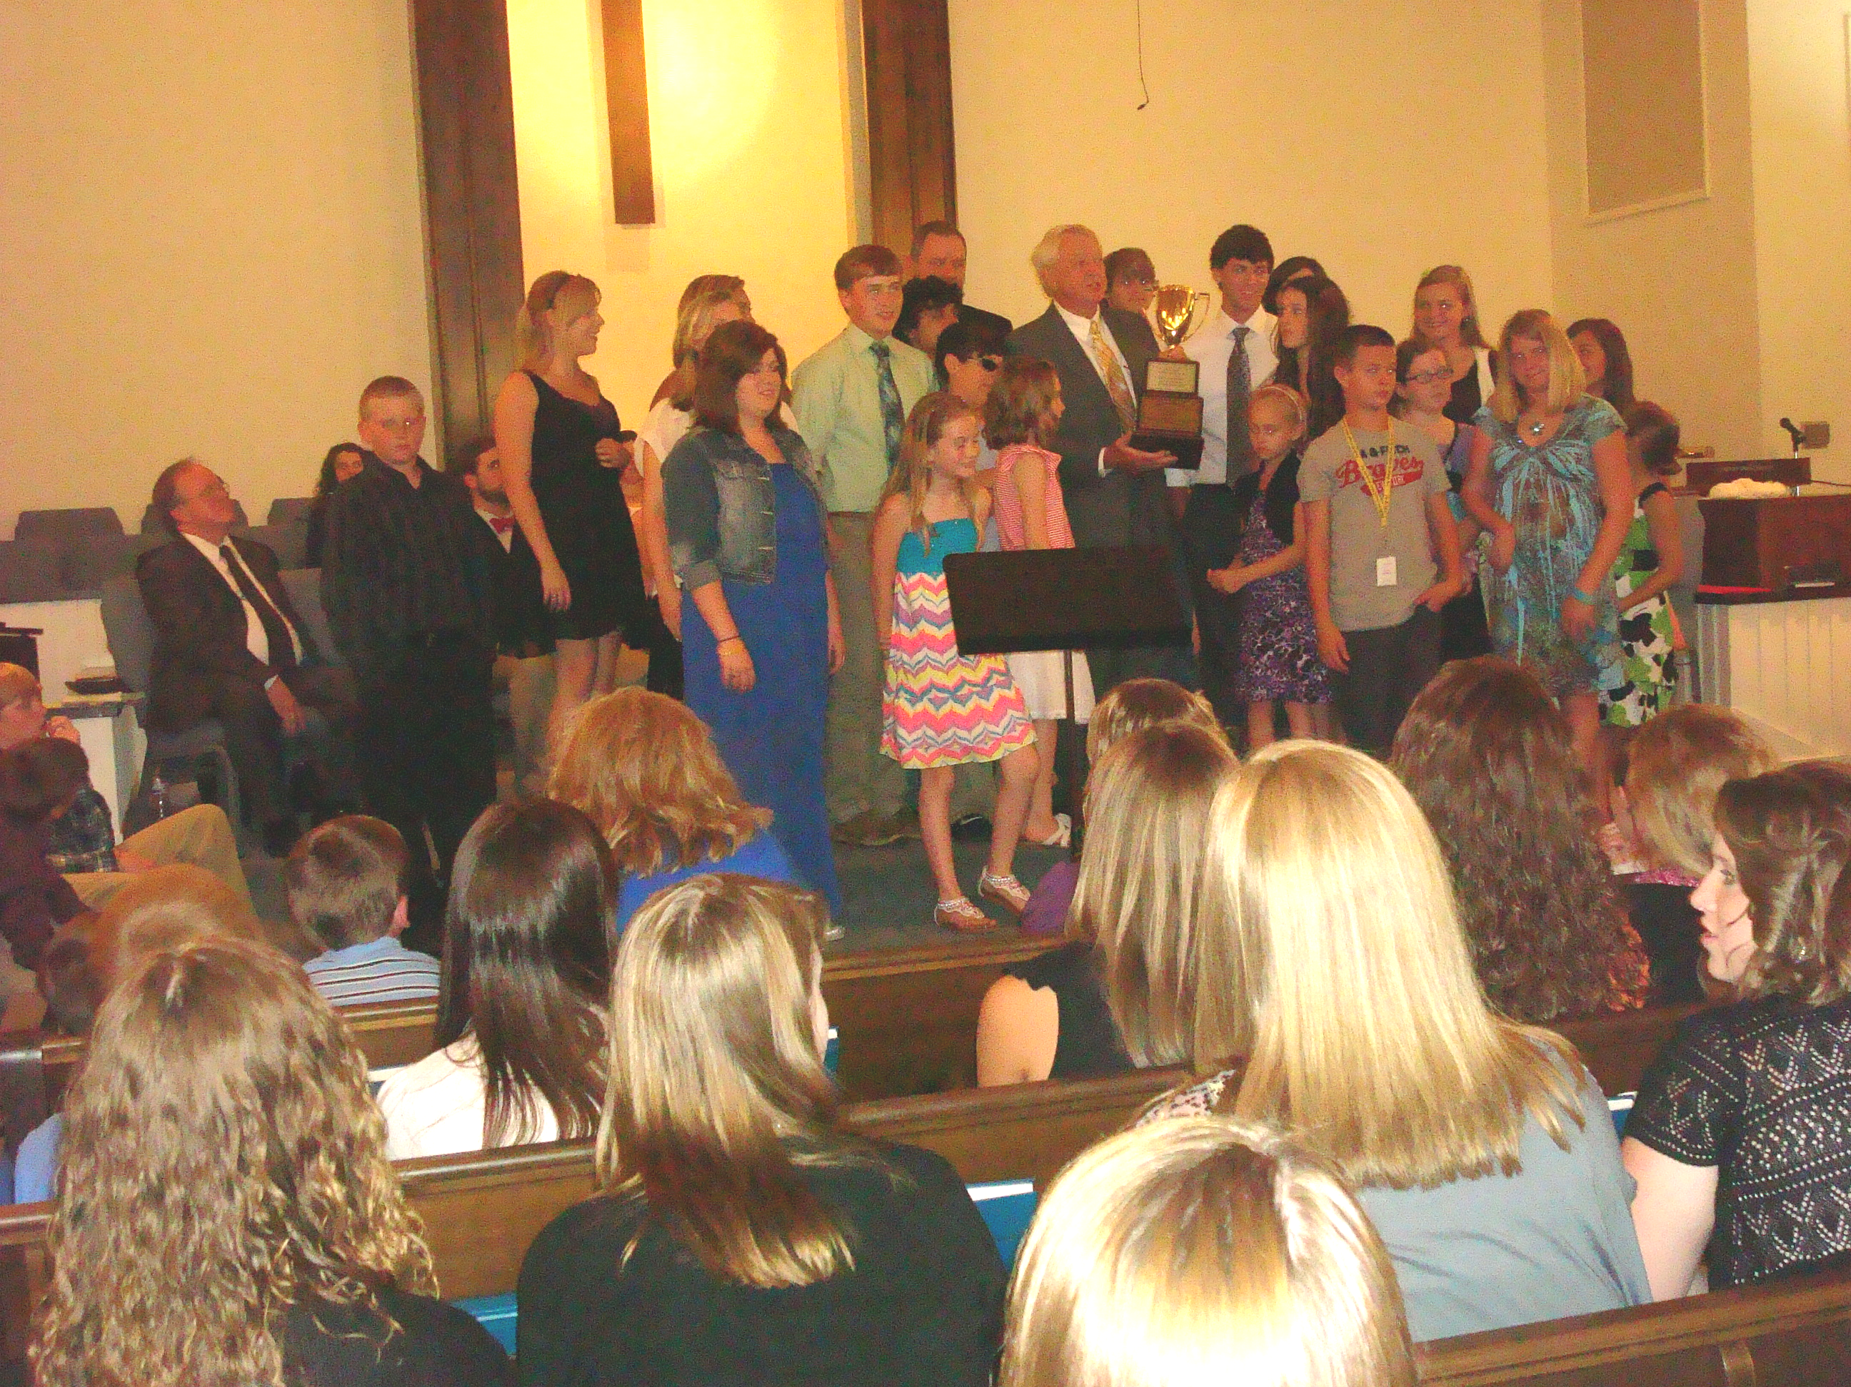

Zack, Christy, Skylar and MaKayla – Participants of Winning Group of Performances

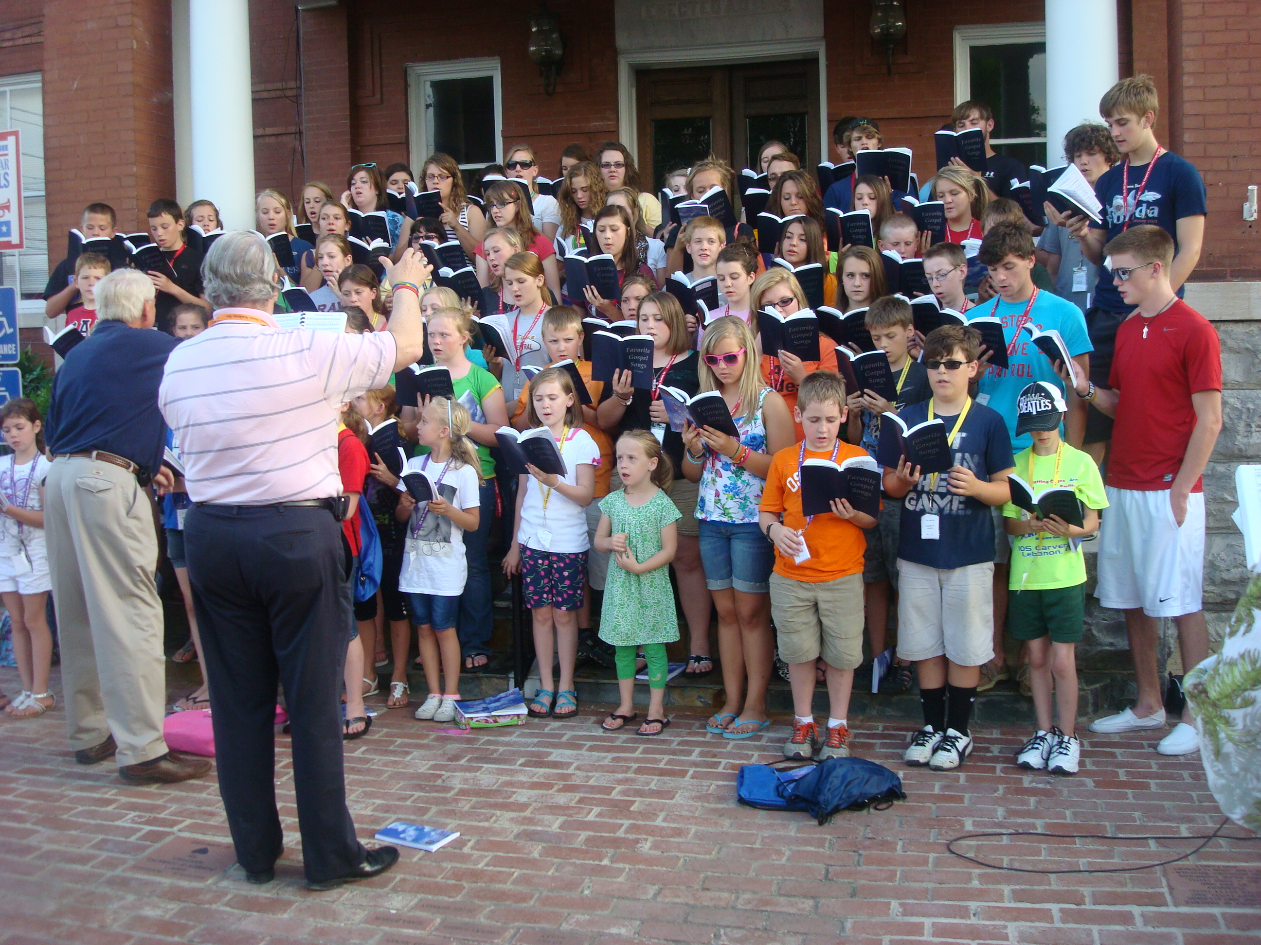
Entire Group of Attendees at Do Re Mi
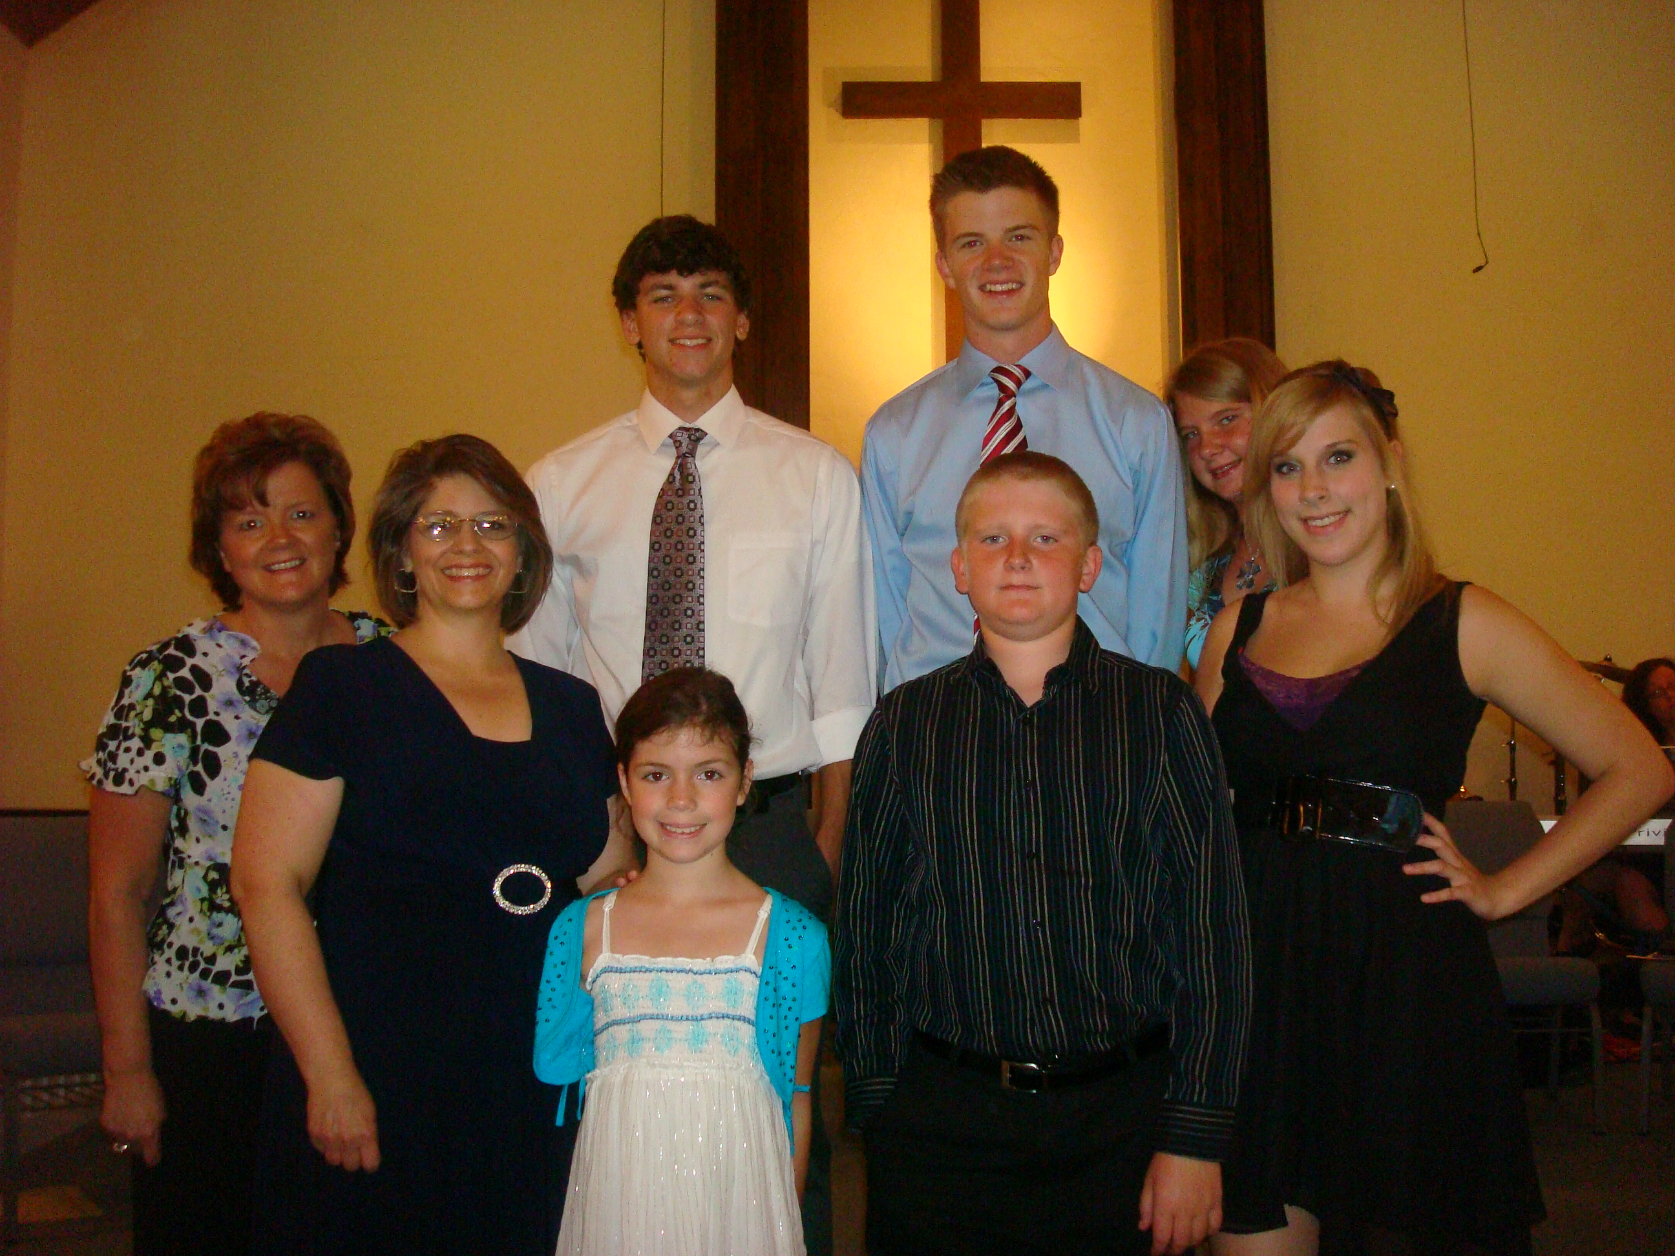

The Birth of a Nation
By David Barton, WALLBUILDERS
For 235 years, America has been blessed as the longest on-going Constitutional Republic in the history of the world. These blessings are not accidental – they are blessings of God. This is evident as we look at the turmoil in other nations and contrast that to the stability we see in America. Preserving American liberty depends first upon our understanding of the foundations on which this great country was built, and then it depends on preserving the principles on which it was founded.
On July 2, 1776, Congress voted to approve a complete separation from England. Two days later, the early draft of the Declaration of Independence was signed. Four days later, members of Congress took the document and read it out loud from the steps of Independence Hall, proclaiming it to the city of Philadelphia, and afterwards they rang the Liberty Bell. The inscription on the top of the bell is Leviticus 25:10, which reads, "Proclaim liberty throughout the land and to all the inhabitants thereof."
John Adams said, "The general principles on which the Fathers achieved independence were the general principles of Christianity." Probably the clearest identification of the spirit of the American Revolution was given by John in a letter to Abigail the day after Congress approved the Declaration. He wrote her two letters that day: One was short and jubilant that the Declaration had been approved; the other letter was much longer and gave serious consideration to what had been done that day. Adams could already foresee that their actions would be celebrated by future generations.
Adams also noted: "This day will be the most memorable epic in the history of America. I am apt to believe that it will be celebrated by succeeding generations as the great anniversary festival." He felt the celebration should be in a manner that would commemorate the day as a "day of deliverance by solemn acts of devotion to God Almighty." John Adams believed that the Fourth of July should be a religious holiday. The two top holidays celebrated in this country are Christmas and the Fourth of July. According to John Quincy Adams, the two dates are connected. On the Fourth of July, the Founding Fathers simply took the precepts of Christ and His birth (Christmas) and incorporated those principles into civil government. The Declaration of Independence was the birth certificate for this nation, but the men who signed it knew it could be their death warrant. The closing paragraph states, "And for the support of this Declaration, with a firm reliance of the protection of Divine Providence, we mutually pledge to each other our lives, our fortunes, and our sacred honor." The 56 Founding Fathers, 27 of whom were trained as ministers, took their pledge seriously. On the morning of the signing, there was silence and gloom as each man was called up to the table of the President of Congress to sign the document, knowing that it could mean their death by hanging.
Most wars have a motto. The motto of World War II was "Remember Pearl Harbor." The motto during the Texas war for independence was "Remember the Alamo." The spiritual emphasis, directed towards King George III who violated God’s laws, gave rise to a motto during the American Revolution: "No King but King Jesus." David reminds us that the Founding Fathers passed the torch to us. It is our responsibility to not let it go out.
“Why don’t you go to church?” asked the minister of a non-churchgoer. “Well, I’ll tell you. The first time I went to church they threw water on me, and the second time they tied me to a woman I’ve had to keep ever since.” “Yes,” said the minister, “and the next time you go they’ll throw dirt on you..”

America The Beautiful

O beautiful for spacious skies,
For amber waves of grain,
For purple mountain majesties
Above the fruited plain!
America! America!
God shed His grace on thee,
And crown thy good with brotherhood
From sea to shining sea!
O beautiful for pilgrim feet
Whose stern impassion'd stress
A thoroughfare for freedom beat
Across the wilderness
America! America!
God mend thine ev'ry flaw,
Confirm thy soul in self-control,
Thy liberty in law.
O beautiful for heroes prov'd
In liberating strife,
Who more than self their country lov'd,
And mercy more than life.
America! America!
May God thy gold refine
Till all success be nobleness,
And ev'ry gain divine.
O beautiful for patriot dream
That sees beyond the years
Thine alabaster cities gleam
Undimmed by human tears.
America! America!
God shed His grace on thee,
And crown thy good with brotherhood
From sea to shining sea.

BIRTHDAYS, WEDDING ANNIVERSARIES
OF FAITH MEMBERS AND CHURCH FAMILY

July 1 – July 8
 HAPPY BIRTHDAY EVERYONE!
Cole Fortson – 7-1 – FIRST BIRTHDAY!!!
Ian Herlein – 7-1 – Birthday
Adam Slate – 7-1 - Birthday
Steve Slate – 7-1 - Birthday
Kyle Schlicher – 7-8 Birthday
Happy Anniversary: Tim and Barbara Shoulders -7-3

Bulletin Committee:
Joyce Callis 352-3070 JoyceCallis38@Comcast.net
Susan Coon– 773-5250 ; Betty Coon- 773-5250 epcn@aol.com
Jean Langford-758-7431 Langford @tds.net
Lisa Parker-274-2783 Lisa274@gmail.com

